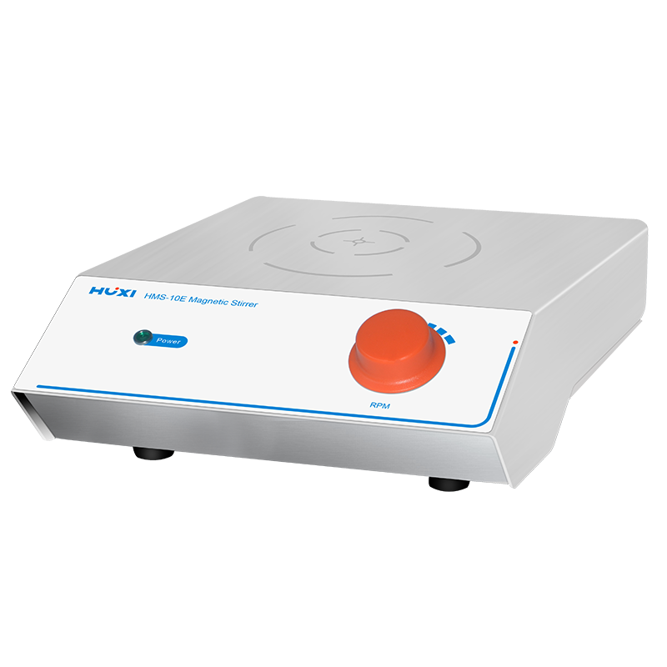

# **HMS-10E Magnetic Stirrer**

**Application：**

HMS-10E magnetic stirrer is suitable for liquids or solid-liquid mixtures that are not very viscous. The magnetic field and vortex principle are used to put the liquid into the container and then put the stirrer into the liquid at the same time, when the magnetic field is generated at the base, it drives the stirrer into circular motion to achieve the purpose of stirring the liquid.

**Main Features：**

* Stepless speed adjustment, stirring evenly, saving time and effort, easy to handle;
* Safety protection device, insurance device, short-circuit protection;
* DC brushless motor, strong power, large torque, large capacity;
* The knob type operation is convenient and quick;
* The choice of 316 stainless steel shell anti-seawater corrosion material;
* Noise reduction treatment, tested to be below 30db noise degree 100% synchronization.

**Techncial Parameters：**

|  |  |
| --- | --- |
| Model | HMS-10E |
| Item No. | 1002040001 |
| Max.Capacity(L) | 10 |
| Model Type | Basic |
| Voltage (V) | 100-240 |
| Frequency(HZ) | 50~60 |
| Timer Range | - |
| Speed Range(rpm) | 50~1800 |
| Speed Display | - |
| Adjust Mode | Knob |
| Motor Type | Brushless motor |
| Motor Power(W) | 10 |
| Shell material | Stainless steel |
| Working plate material | Stainless steel |
| Allowable ambient humidity（%） | 80 |
| Allowable ambient temperature(℃) | 5-35 |
| Instrument Size(mm) | 252*150*75 |
| Packing Size(mm) | 325*270*180 |
| NW(kg) | 2.5 |
| GW(kg) | 1.9 |